Single-Heater Resistor Comparison
Setup 2: two 7.5 Ω resistors versus two 10 Ω resistors
Report type | Comparative thermal step-response analysis
Input records | 15 Ω reference experiment and Setup2_10Ohm.txt
Comparison window | First 150 s after the 100% heater command
Purpose
Quantify how increasing the heater resistance from 15 Ω to 20 Ω changes electrical power, local heating rate, thermal gain, propagation delay, time constant, and the temperature profile along the PCB beam.
Key result. At the same nominal 5 V supply, the 20 Ω heater receives 25% less electrical power. Its initial Sensor 1 heating rate is 22.8% lower, close to the expected power reduction. After 150 s, the 20 Ω heater is 15.3% cooler at Sensor 1 but nearly equal at the far sensors, producing a flatter temperature profile.
Prepared from recorded temperature and PWM data

Executive Summary
● Electrical input: The 15 Ω heater draws approximately 0.333 A and 1.667 W at 5 V. The 20 Ω heater draws approximately 0.250 A and 1.250 W.
● Near-heater response: Sensor 1 reaches an ambient-corrected rise of 87.40°C for the 15 Ω heater and 73.99°C for the 20 Ω heater after 150 s.
● Initial heating rate: The measured Sensor 1 slope ratio is 0.772, compared with a nominal electrical power ratio of 0.750.
● Response speed: The practical 63.2% response time is approximately 12–14% longer for the 20 Ω experiment across all five sensors.
● Spatial profile: The end-to-end temperature gradient is reduced by approximately 19%, making the 20 Ω configuration more spatially uniform.
● Modeling implication: A single 0.75 gain multiplier is adequate only for the earliest near-heater response. Separate transfer-function parameters are recommended for accurate prediction along the complete beam.

Headline comparison at 150 seconds
Sensor | 15 Ω rise | 20 Ω rise | 20 Ω / 15 Ω | 20 Ω change
S1 | 87.40°C | 73.99°C | 84.7% | -15.3%
S2 | 59.71°C | 52.71°C | 88.3% | -11.7%
S3 | 33.04°C | 30.25°C | 91.6% | -8.4%
S4 | 20.04°C | 19.58°C | 97.7% | -2.3%
S5 | 14.18°C | 14.81°C | 104.5% | +4.5%
Table 1. Ambient-corrected temperature rise measured 150 s after the 100% heater command.

1. Test Configurations and Electrical Expectation
Both tests use one heater element driven at 100% PWM from the same nominal 5 V supply. The only intentional electrical change is the total series resistance of the two heater resistors.
$$R_{15} = 7.5 Ω + 7.5 Ω = 15 Ω$$
$$R_{20} = 10 Ω + 10 Ω = 20 Ω$$
$$I = \frac{V}{R} and P = \frac{V^{2}}{R}$$
Configuration | Total R | Current at 5 V | Total power | Power/resistor
2 × 7.5 Ω | 15 Ω | 0.333 A | 1.667 W | 0.833 W
2 × 10 Ω | 20 Ω | 0.250 A | 1.250 W | 0.625 W
$$\frac{P_{20}}{P_{15}} = \frac{1.250}{1.667} = 0.750$$
Electrical expectation: at equal voltage and duty cycle, the 20 Ω heater should deliver 75% of the 15 Ω heater power and therefore show approximately 25% less initial heating rate before thermal losses become strongly temperature dependent.

2. Data Processing and Identification Method
• The records were aligned at the transition to 100% Heater 1 PWM.
• Each sensor was converted to a relative temperature rise using its own pre-step baseline. Ambient drift was removed so static calibration offsets do not affect the comparison.
• Because the 20 Ω pulse lasts 151.162 s while the 15 Ω reference pulse lasts 324.844 s, the direct sample comparison uses the common 0–150 s window.
• A first-order-plus-dead-time model was fitted to each heater-to-sensor response.
$$G_{i}(s) = \frac{K_{i}e^{−Lᵢs}}{τ_{i}s + 1}$$
Here, K is the asymptotic temperature-rise gain, L is the apparent delay, and τ is the dominant first-order time constant. The practical response time is measured at 63.2% of the observed 150 s rise, while the model response time is L + τ.

3. Measured Step Responses
Figure 1 overlays the actual ambient-corrected samples from both experiments. The effect of the resistance change is strongest at Sensors 1 and 2. The traces converge progressively with distance from the heater.
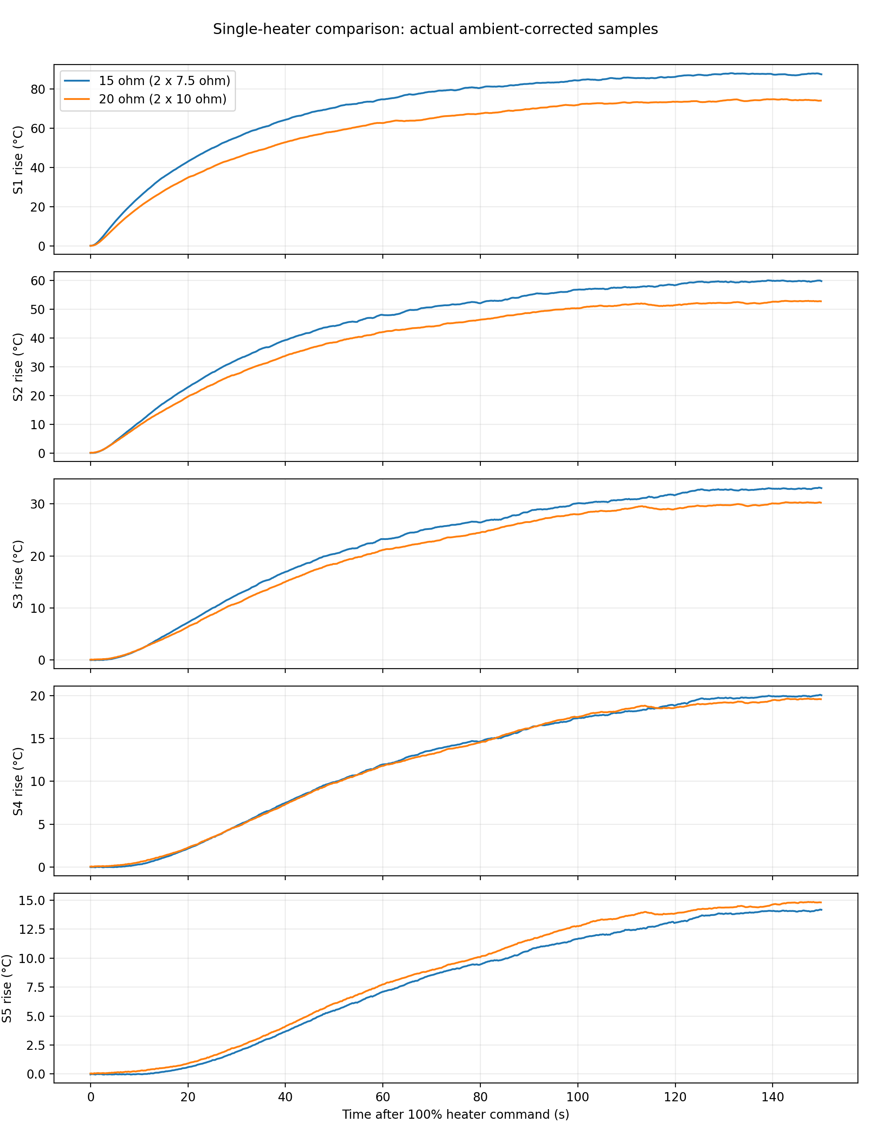
Figure 1. Actual samples aligned to the 100% heater command, shown over the common 0–150 s interval.

4. Sensor-by-Sensor Thermal Comparison
The measured 150 s rise and practical 63.2% response times are summarized below. The 20 Ω heater is distinctly cooler near the heater but nearly equal at the far end of the beam.
Sensor | 15 Ω rise | 20 Ω rise | Rise ratio | 15 Ω t₆₃ | 20 Ω t₆₃ | Time change
S1 | 87.40 | 73.99 | 84.7% | 28.67 | 32.19 | +12.3%
S2 | 59.71 | 52.71 | 88.3% | 34.91 | 39.32 | +12.6%
S3 | 33.04 | 30.25 | 91.6% | 46.13 | 52.36 | +13.5%
S4 | 20.04 | 19.58 | 97.7% | 57.16 | 64.17 | +12.3%
S5 | 14.18 | 14.81 | 104.5% | 65.25 | 73.20 | +12.2%
Table 2. Temperature rise in °C and practical response time in seconds. Time change is the increase from 15 Ω to 20 Ω.
Initial Sensor 1 slope  15 Ω: 2.90 °C/s  20 Ω: 2.24 °C/s  Measured ratio: 0.772 | End-to-end gradient at 150 s  15 Ω: 73.22 °C  20 Ω: 59.18 °C  Reduction: 19.2%

5. First-Order Model Comparison
The fitted gains and time constants show that the lower-power 20 Ω experiment cannot be represented accurately by multiplying every 15 Ω path by 0.75. The near-heater gain falls, while the apparent gains at the distant sensors increase because the lower-temperature test experiences less nonlinear heat loss and because the shorter record limits steady-state observability.

15 Ω heater: two 7.5 Ω resistors
Sensor | K (°C) | L (s) | τ (s) | L + τ (s) | RMSE | R²
S1 | 86.97 | 0.16 | 29.59 | 29.75 | 1.00 | 0.9965
S2 | 58.84 | 3.39 | 33.36 | 36.75 | 1.28 | 0.9905
S3 | 32.25 | 11.05 | 37.84 | 48.90 | 1.22 | 0.9793
S4 | 19.46 | 20.31 | 38.80 | 59.11 | 1.02 | 0.9692
S5 | 13.71 | 29.31 | 37.84 | 67.15 | 0.86 | 0.9630

20 Ω heater: two 10 Ω resistors
Sensor | K (°C) | L (s) | τ (s) | L + τ (s) | RMSE | R²
S1 | 75.26 | 0.00 | 33.20 | 33.20 | 0.61 | 0.9990
S2 | 54.21 | 2.44 | 38.90 | 41.35 | 0.37 | 0.9994
S3 | 32.74 | 8.88 | 50.12 | 59.01 | 0.42 | 0.9980
S4 | 22.86 | 14.74 | 62.90 | 77.64 | 0.38 | 0.9967
S5 | 18.46 | 20.56 | 72.47 | 93.03 | 0.33 | 0.9959

6. Normalized Response Shape
After normalization to each experiment’s own 150 s amplitude, the response shapes are very similar. This indicates that the PCB’s heat-propagation mechanism is largely unchanged by the resistor value; the main differences are input power, operating temperature, and the apparent time-scale shift caused by the lower signal level.
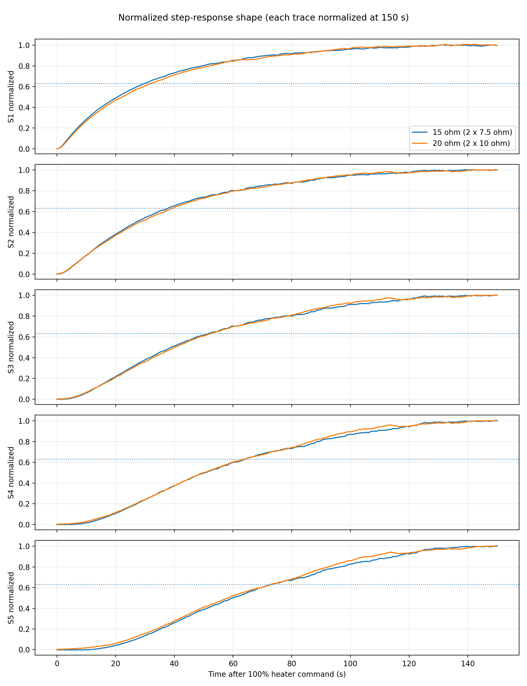
Figure 2. Normalized sensor traces. The dotted line marks the 63.2% criterion used for practical response-time comparison.

7. Temperature Distribution Along the Beam
Figure 3 compares the spatial temperature-rise profile at 30, 60, 90, 120, and 150 seconds. The 15 Ω heater produces the larger local peak. The difference decreases with distance, so the 20 Ω heater generates a flatter profile.
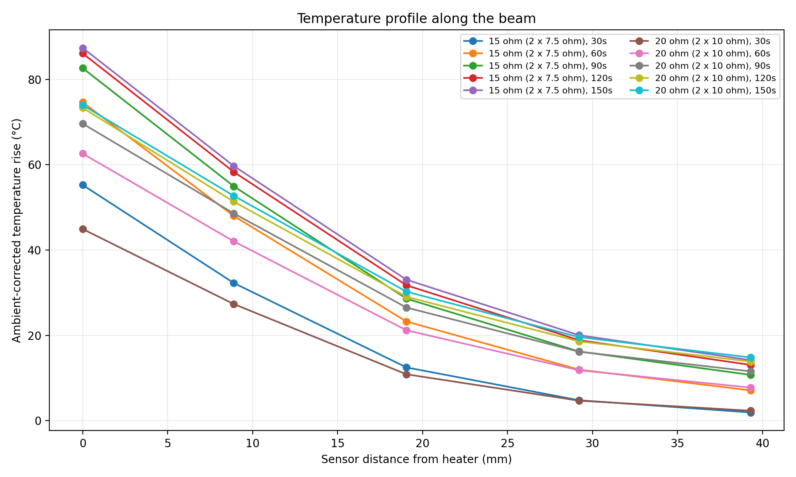
Figure 3. Ambient-corrected temperature rise versus sensor distance from the heater.
Metric | 15 Ω | 20 Ω
S1–S5 gradient at 150 s | 73.22°C | 59.18°C
S5 / S1 rise ratio | 0.162 | 0.200
Nominal power | 1.667 W | 1.250 W

8. Engineering Interpretation

8.1 Agreement with electrical theory
The initial Sensor 1 heating-rate ratio is 0.772. This is close to the theoretical power ratio of 0.750 and confirms that the resistance change behaves as expected during the early transient, when the board temperature and temperature-dependent losses are still similar.

8.2 Why the 150-second temperature ratio is greater than 0.75
• Convection and radiation losses grow as the heater and PCB become hotter, so the higher-power 15 Ω case loses a larger fraction of its input power to the surroundings.
• The hotter resistor packages may transfer more heat directly to the air instead of into the beam.
• The tests begin at different absolute temperatures and may have small differences in mounting, airflow, or actual supply voltage.
• The 20 Ω test ends after about 151 s, so the distant sensors do not provide a fully established steady-state gain.
• The far-sensor signal is small; minor baseline and ambient corrections become a larger percentage of the measured rise.

8.3 Temperature rise per nominal watt
The 20 Ω test shows a greater recorded temperature rise per nominal watt, particularly at the distant sensors. This should not be interpreted as a change in electrical conversion efficiency. It is an apparent system-level result caused by lower operating temperature, nonlinear thermal losses, record duration, and test-to-test conditions.
Sensor | 15 Ω °C/W | 20 Ω °C/W | Relative change
S1 | 52.44 | 59.19 | +12.9%
S2 | 35.82 | 42.16 | +17.7%
S3 | 19.82 | 24.20 | +22.1%
S4 | 12.02 | 15.66 | +30.3%
S5 | 8.51 | 11.85 | +39.3%

9. Conclusions and Recommended Use
✓ Power: At 5 V, the 20 Ω heater uses 1.25 W instead of 1.67 W, reducing nominal input power by 25%.
✓ Heating rate: The early Sensor 1 response agrees closely with the expected power ratio.
✓ Peak temperature: The 20 Ω heater reduces the near-heater temperature substantially and is preferable when resistor stress or local peak temperature is the primary concern.
✓ Uniformity: The lower-power heater creates a flatter temperature field and a smaller end-to-end gradient.
✓ Response speed: The 15 Ω heater reaches a given fraction of its 150 s response roughly 12–14% sooner.
✓ Model selection: Use separate identified transfer functions for the two resistor configurations. Do not apply one uniform 0.75 gain multiplier when predicting all sensors.

9.1 Configuration Selection
Choose 15 Ω when  • faster warm-up is needed  • higher local temperature is acceptable  • maximum heat input is required | Choose 20 Ω when  • lower resistor dissipation is desired  • local peak temperature must be reduced  • a flatter beam profile is preferred

10. Limitations and Next Measurement
The comparison uses nominal 5 V power because supply voltage and heater current were not logged. A higher-confidence power-normalized comparison requires synchronized voltage and current measurements at the heater terminals. Repeating both tests with the same pulse duration, initial board temperature, mounting condition, and airflow would separate resistor-value effects from run-to-run variation.
Recommended next experiment: record heater-terminal voltage and current, hold both pulses for at least 300 s, and repeat each configuration twice. This would allow direct normalization by measured electrical energy and a stronger uncertainty estimate for K, L, and τ.

Appendix A. Identified Transfer Functions
The following FOPDT parameters use normalized heater duty as the input, where u = 1 corresponds to 100% PWM. For PWM expressed from 0 to 100, divide each gain K by 100.

A.1 15 Ω heater
Sensor 1: $G_{1}(s) = \frac{86.97e^{−0.16s}}{29.59s + 1}$
Sensor 2: $G_{2}(s) = \frac{58.84e^{−3.39s}}{33.36s + 1}$
Sensor 3: $G_{3}(s) = \frac{32.25e^{−11.05s}}{37.84s + 1}$
Sensor 4: $G_{4}(s) = \frac{19.46e^{−20.31s}}{38.80s + 1}$
Sensor 5: $G_{5}(s) = \frac{13.71e^{−29.31s}}{37.84s + 1}$

A.2 20 Ω heater
Sensor 1: $G_{1}(s) = \frac{75.26e^{−0.00s}}{33.20s + 1}$
Sensor 2: $G_{2}(s) = \frac{54.21e^{−2.44s}}{38.90s + 1}$
Sensor 3: $G_{3}(s) = \frac{32.74e^{−8.88s}}{50.12s + 1}$
Sensor 4: $G_{4}(s) = \frac{22.86e^{−14.74s}}{62.90s + 1}$
Sensor 5: $G_{5}(s) = \frac{18.46e^{−20.56s}}{72.47s + 1}$
Data files used in this report: Setup2_10Ohm.txt and the previously analyzed 15 Ω Setup 2 recording. Derived comparison tables and plots were generated from the aligned, ambient-corrected records.

